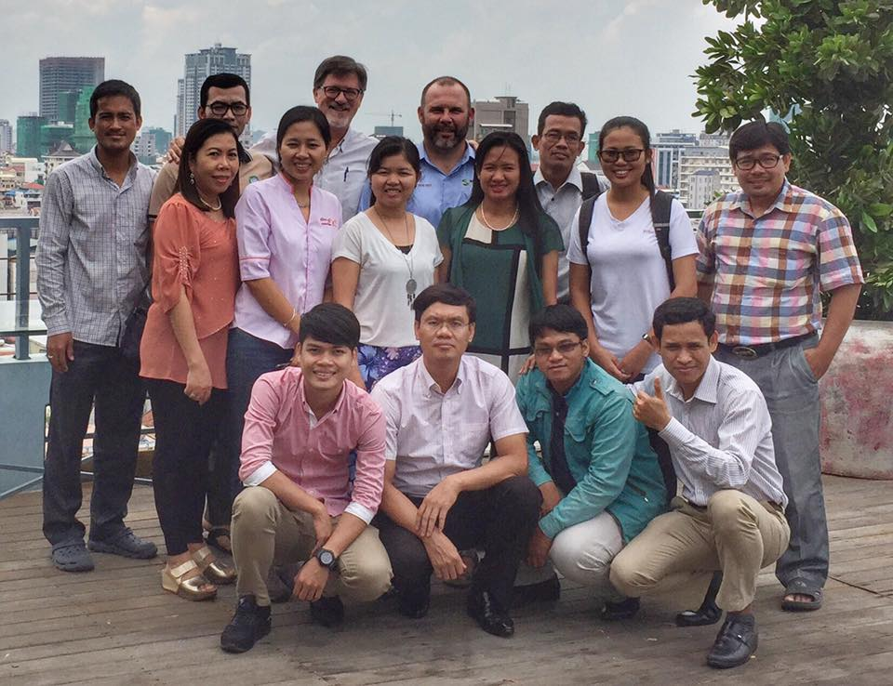

Cohort 1 2016
Cambodia

Participants Name | Organization | Title
Samnang Tep | Evangelical Fellowship of Cambodia | Executive Director
Chantara Teang | Clear Cambodia | Ministry Manager
Koy Chim | Cambodians Care | Director/Founder
Romroth Chuon | World Relief | Program Operations Manager
Chandara Ket | Micah Cambodia | National Coordinator
Chan Saron | Chap Dai | Senior Program Manager
Ravuth Ma | Evangelical Fellowship of Cambodia | Deputy Director
Sovannry Lan | Women of Hope | Founder/Director
IM Chetra | Mlup Russey Organization | Community Sector Manager
Solida Seng | Precious Women | Founder and Director
Dara Pitou Somel | Precious Women | Butterfly Program Coordinator
Manith Yin | Mlup Russey Organization | Executive Director
Sokun Ros | Wholistic Development Organization (WDO) | Project Manager
Sreylieap Khorn | Food for the Hungry Cambodia | Communication and Resource Mobilization Officer
Channy Nop | Sunshine Cambodia | Director

